

Compensation and Pension Record Interchange (CAPRI)

Ischemic Heart Disease (IHD)

Disability Benefits Questionnaire (DBQ)

Workflow

February 2011

Department of Veterans Affairs
Office of Enterprise Development
Management & Financial Systems

Revision History

Date | Description (Patch # if applicable) | Author | Technical Writer
08/02/2010 | Document created for patch 154. | Cindi Gawronski | Jill Headen
08/17/2010 | Added ICD codes and other misc changes for patch 154. | Cindi Gawronski | Jill Headen
10/12/2010 | Answering ‘No’ to Section 5: Is there evidence of cardiac hypertrophy or dilatation? Allows user to reference the source and date of the test for patch 159. | Cindi Gawronski | N/A
10/28/2010 | Changed wording in Introduction for patch 159. | Cindi Gawronski | N/A
11/2/2010 | Added wording in Note in Diagnosis 1 for patch 159. | Cindi Gawronski | N/A
12/28/2010 | Moved IHD Note for patch 161. | Cindi Gawronski | N/A
02/07/2011 | Change to Section 4.b. MET’s testing (Patch 161) | Jeremiah Dawson | N/A

Table of Contents

1 Introduction 2
1.1 Purpose 2
1.2 Overview 2
2 Ischemic Heart Disease (IHD) DBQ – History Tab 3
2.1 Name of patient/Veteran 3
2.2 Section 1. Diagnosis 4
2.3 Section 2. Medical history 8
2.4 Section 3. Congestive heart failure (CHF) 11
2.5 Section 4. Cardiac functional assessment 12
2.6 Section 5. Diagnostic testing 15
2.7 Section 6. Functional impact 18
2.8 Section 7. Remarks, if any 20
3 IHD AMIE-DBQ Worksheet 21

Table of Tables and Figures

Table 1: Rules: DBQ – IHD – Name of patient/Veteran 3
Table 2: Rules: DBQ – IHD – 1. Diagnosis 5
Table 3: Rules: DBQ – IHD – 2. Medical history 8
Table 4: Rules: DBQ – IHD – 3. Congestive heart failure (CHF) 11
Table 5: Rules: DBQ – IHD – 4. Cardiac functional assessment 13
Table 6: Rules: DBQ – IHD – 5. Diagnostic testing 16
Table 7: Rules: DBQ – IHD – 6. Functional impact 19
Table 8: Rules: DBQ – IHD – 7. Remarks, if any 20

Figure 1: Template Example: DBQ – Standard VA Note 2
Figure 2: Print Example: DBQ – Standard VA Note 2
Figure 3: Template Example: DBQ – IHD – Name of patient/Veteran 3
Figure 4: Print Example: DBQ – IHD – Name of patient/Veteran 3
Figure 5: Template Example: DBQ – IHD – 1. Diagnosis 7
Figure 6: Print Example: DBQ – IHD – 1. Diagnosis 7
Figure 7: Template Example: DBQ – IHD – 2. Medical history 10
Figure 8: Print Example: DBQ – IHD – 2. Medical history 11
Figure 9: Template Example: DBQ – IHD – 3. Congestive heart failure (CHF) 12
Figure 10: Print Example: DBQ – IHD – 3. Congestive heart failure (CHF) 12
Figure 11: Template Example: DBQ – IHD – 4. Cardiac functional assessment 14
Figure 12: Print Example: DBQ – IHD – 4. Cardiac functional assessment 15
Figure 13: Template Example: DBQ – IHD – 5. Diagnostic testing 17
Figure 14: Print Example: DBQ – IHD – 5. Diagnostic testing 18
Figure 15: Template Example: DBQ – IHD – 6. Functional impact 19
Figure 16: Print Example: DBQ – IHD – 6. Functional impact 19
Figure 17: Template Example: DBQ – IHD – 7. Remarks, if any 20
Figure 18: Print Example: DBQ – IHD – 7. Remarks, if any 20

Introduction

Purpose
This document provides a high level overview of the contents found on the Ischemic Heart Disease (IHD) Disability Benefits Questionnaire (DBQ). The DBQ can be populated via an online template within the CAPRI C&P Worksheets tab and then printed OR it can be printed via AMIE (AUTOMATED MEDICAL INFORMATION EXCHANGE) and then manually populated. This document contains the edit rules for the template as well as an example of how the template will look online in CAPRI or printed from CAPRI. It also contains the layout for the AMIE worksheet to depict how it will look when printed from AMIE.

For more detailed information on standard template functionality not covered in this document, please refer to the C&P Worksheet Tab Functionalities section of the CAPRI GUI User Guide.

Overview
The Ischemic Heart Disease (IHD) DBQ provides the ability to capture information related to IHD and its treatment.

Each DBQ template contains a standard footer containing a note stating that “VA may request additional medical information, including additional examinations if necessary to complete VA’s review of the Veteran’s application.” (see Figure 1 and 2).

Figure 1: Template Example: DBQ – Standard VA Note
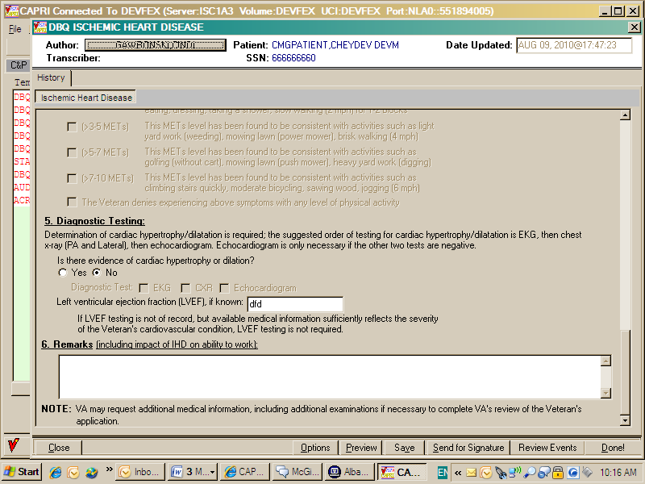

Figure 2: Print Example: DBQ – Standard VA Note

NOTE: VA may request additional medical information, including additional

examinations if necessary to complete VA's review of the Veteran's application.

A number of fields on the Ischemic Heart Disease (IHD) template are mandatory and require a response (value) prior to the exam being marked as completed. Some questions may activate a Pop-up window displaying information as to each question that needs to be answered before the template can be completed.

Ischemic Heart Disease (IHD) DBQ – History Tab

Name of patient/Veteran
All questions in this section must be answered as described by the rules below. If all mandatory questions are not answered, the error message(s) will appear in a popup window as depicted below.

Table 1: Rules: DBQ – IHD – Name of patient/Veteran
Field/Question | Field Disposition | Valid Values | Format | Error Message
Disability Benefits Questionnaire | Disabled, Read-Only | N/A | N/A | N/A
Ischemic Heart Disease (IHD) | Disabled, Read-Only | N/A | N/A | N/A
Name of patient/Veteran | Enabled, Mandatory | N/A | Free Text | Please enter the name of the patient/Veteran.
Your patient is applying to the U. S. Department of Veterans Affairs (VA) for disability benefits. VA will consider the information you provide on this questionnaire as part of their evaluation in processing the Veteran’s claim. | Disabled, Read-Only | N/A | N/A | N/A

Figure 3: Template Example: DBQ – IHD – Name of patient/Veteran

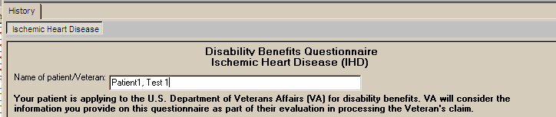

Figure 4: Print Example: DBQ – IHD – Name of patient/Veteran

Disability Benefits Questionnaire
Ischemic Heart Disease (IHD)
Name of patient/Veteran: Patient1, Test 1
Your patient is applying to the U.S. Department of Veterans Affairs (VA) for
disability benefits. VA will consider the information you provide on this
questionnaire as part of their evaluation in processing the Veteran's claim.

Section 1. Diagnosis
The question “Does the Veteran have ischemic heart disease (IHD)?” must be answered before this template can be completed.

- If it is answered with Yes, all other questions requiring an answer as described by the rules in this document must be answered before the template can be completed.
- If it is answered with No, the template may be completed without answering any additional questions or the user may input answers to any of the optional questions as indicated by the rules described in this document.

All questions will be printed even if they have not been answered.

If all mandatory questions are not answered, the error message(s) will appear in a popup window as depicted below and must be answered before this template can be completed.

Table 2: Rules: DBQ – IHD – 1. Diagnosis
Field/Question | Field Disposition | Valid Values | Format | Error Message
1. Diagnosis | Disabled; Read-Only | N/A | N/A | N/A
NOTE: IHD includes, but is not limited to, acute, subacute, and old myocardial infarction; atherosclerotic cardiovascular disease including coronary artery disease (including coronary spasm) and coronary bypass surgery; and stable, unstable and Prinzmetal’s angina. IHD does not include hypertension or peripheral manifestations of arteriosclerosis such as peripheral vascular disease or stroke, or any other condition that does not qualify within the generally accepted medical definition of ischemic heart disease.  IHD encompasses any atherosclerotic heart disease resulting in clinically significant ischemia or requiring coronary revascularization. | Disabled, Read Only | N/A | N/A | N/A
Does the Veteran have ischemic heart disease (IHD)? | Enabled, Mandatory, Choose one valid value | [Yes; No] | N/A | Please answer the question: Does the Veteran have ischemic heart disease (IHD)?
NOTE: Provide only diagnoses that pertain to IHD. | Disabled, Read Only | N/A | N/A | N/A
Diagnosis #1: | If diagnosis = Yes; Enabled, Mandatory  Else; Enabled, Optional | N/A | Free Text | Please enter a value in the ‘Diagnosis #1’ field.
ICD code: | If diagnosis = Yes; Enabled, Mandatory  Else; Enabled, Optional | N/A | Free Text | Please enter the ICD code for diagnosis #1.
Date of diagnosis #1: | If diagnosis = Yes; Enabled, Mandatory  Else; Enabled, Optional | N/A | Free Text | Please enter the date of diagnosis #1.
Diagnosis #2: | Enabled, Optional | N/A | Free Text | N/A
ICD code: | If Diagnosis #2 is populated; Enabled, Mandatory  Else; Enabled, Optional | N/A | Free Text | Please enter the ICD code for diagnosis #2.
Date of diagnosis #2: | If Diagnosis #2 is populated; Enabled, Mandatory  Else; Enabled, Optional | N/A | Free Text | Please enter the date of diagnosis #2.
Diagnosis #3: | Enabled, Optional | N/A | Free Text | N/A
ICD code: | If Diagnosis #3 is populated; Enabled, Mandatory  Else; Enabled, Optional | N/A | Free Text | Please enter the ICD code for diagnosis #3.
Date of diagnosis #3: | If Diagnosis #3 is populated; Enabled, Mandatory  Else; Enabled, Optional | N/A | Free Text | Please enter the date of diagnosis #3.
If additional diagnoses that pertain to IHD, list using above format: | Enabled, Optional | N/A | Free Text | N/A
Figure 5: Template Example: DBQ – IHD – 1. Diagnosis
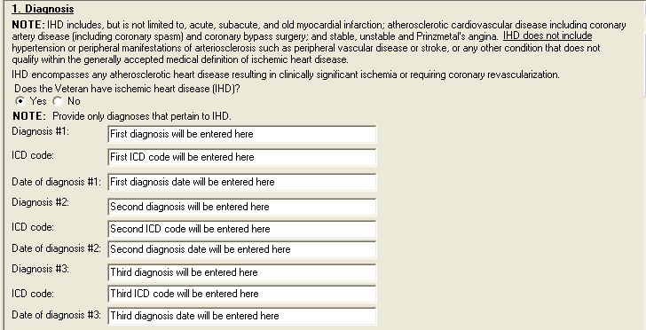
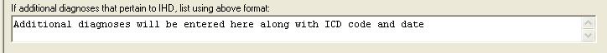

Figure 6: Print Example: DBQ – IHD – 1. Diagnosis
1. Diagnosis
------------
NOTE: IHD includes, but is not limited to, acute, subacute, and old
myocardial infarction; atherosclerotic cardiovascular disease including
Coronary artery disease (including coronary spasm) and coronary bypass
surgery; and stable, unstable and Prinzmetal's angina. IHD does not
include hypertension or peripheral manifestations of arteriosclerosis such
as peripheral vascular disease or stroke, or any other condition that does
not qualify within the generally accepted medical definition of ischemic
heart disease.
IHD encompasses any atherosclerotic heart disease resulting in clinically
significant ischemia or requiring coronary revascularization.
Does the Veteran have ischemic heart disease (IHD)? [X] Yes [ ] No
NOTE: Provide only diagnoses that pertain to IHD.
Diagnosis #1: First diagnosis will be entered here
ICD code: First ICD code will be entered here
Date of diagnosis #1: First diagnosis date will be entered here
Diagnosis #2: Second diagnosis will be entered here
ICD code: Second ICD code will be entered here
Date of diagnosis #2: Second diagnosis date will be entered here
Diagnosis #3: Third diagnosis will be entered here
ICD code: Third ICD code will be entered here
Date of diagnosis #3: Third diagnosis date will be entered here
If additional diagnoses that pertain to IHD, list using above format:
Additional diagnoses will be entered here along with ICD code and date

Section 2. Medical history
All questions in this section may be answered as described by the rules below. If all mandatory questions are not answered, the error message(s) will appear in a popup window as depicted below and must be answered before this template can be completed.

Table 3: Rules: DBQ – IHD – 2. Medical history
Field/Question | Field Disposition | Valid Values | Format | Error Message
2. Medical history | Disabled; Read-Only | N/A | N/A | N/A
Does the Veteran's treatment plan include taking continuous medication for the diagnosed condition? | If diagnosis = Yes; Enabled, Mandatory, Choose one valid value  Else; Enabled, Optional | [Yes; No] | N/A | Please answer the question: Does the Veteran's treatment plan include taking continuous medication for the diagnosed condition?
List medications: | If preceding question = Yes; Enabled, Mandatory  Else; Disabled | N/A | Free Text | Please list medications.
Is there a History of: | Disabled, Read Only | N/A | N/A | N/A
Percutaneous coronary intervention (PCI) | If diagnosis = Yes; Enabled, Mandatory, Choose one valid value  Else; Enabled, Optional | [Yes; No] | N/A | Please answer whether or not there is a history of percutaneous coronary intervention (PCI).
Percutaneous coronary intervention Treatment facility/date: | If History of PCI = Yes; Enabled, Mandatory  Else; Disabled | N/A | Free Text | Please enter the percutaneous coronary intervention (PCI) treatment facility/date.
Myocardial infarction | If diagnosis = Yes; Enabled, Mandatory, Choose one valid value  Else; Enabled, Optional | [Yes; No] | N/A | Please answer whether or not there is a history of myocardial Infarction.
Myocardial infarction Treatment facility/date: | If History of Myocardial infarction = Yes; Enabled, Mandatory  Else; Disabled | N/A | Free Text | Please enter the myocardial infarction treatment facility/date.
Coronary bypass surgery | If diagnosis = Yes; Enabled, Mandatory, Choose one valid value  Else; Enabled, Optional | [Yes; No] | N/A | Please answer whether or not there is a history of coronary bypass surgery.

Field/Question | Field Disposition | Valid Values | Format | Error Message
Coronary bypass surgery Treatment facility/date: | If History of Coronary bypass surgery = Yes; Enabled, Mandatory  Else; Disabled | N/A | Free Text | Please enter the coronary bypass surgery treatment facility/date.
Heart transplant | If diagnosis = Yes; Enabled, Mandatory, Choose one valid value  Else; Enabled, Optional | [Yes; No] | N/A | Please answer whether or not there is a history of heart transplant.
Heart transplant Treatment facility/date: | If History of Heart transplant = Yes; Enabled, Mandatory  Else; Disabled | N/A | Free Text | Please enter the heart transplant treatment facility/date.
If yes, is it as likely as not that the Veteran’s heart transplant is due to IHD? | If History of Heart transplant = Yes; Enabled, Mandatory, Choose one valid value  Else; Disabled | [Yes; No] | N/A | Please provide an answer to the question: If yes, is it as likely as not that the Veteran's heart transplant is due to IHD?
Implanted cardiac pacemaker | If diagnosis = Yes; Enabled, Mandatory, Choose one valid value  Else; Enabled, Optional | [Yes; No] | N/A | Please answer whether or not there is a history of Implanted cardiac pacemaker.
Implanted cardiac pacemaker Treatment facility/date: | If History of Implanted cardiac pacemaker = Yes; Enabled, Mandatory  Else; Disabled | N/A | Free Text | Please enter the implanted cardiac pacemaker treatment facility/date.
If yes, is it as likely as not that the Veteran’s pacemaker is due to IHD? | If History of Implanted cardiac pacemaker = Yes; Enabled, Mandatory, Choose one valid value  Else; Disabled | [Yes; No] | N/A | Please provide an answer to the question: If yes, is it as likely as not that the Veteran's pacemaker is due to IHD?
Implanted automatic implantable cardioverter defibrillator (AICD) | If diagnosis = Yes; Enabled, Mandatory, Choose one valid value  Else; Enabled, Optional | [Yes; No] | N/A | Please answer whether or not there is a history of implanted automatic implantable cardioverter defibrillator (AICD).
Implanted automatic implantable cardioverter defibrillator (AICD)  Treatment facility/date: | If History of AICD = Yes; Enabled, Mandatory  Else; Disabled | N/A | Free Text | Please enter the implanted automatic implantable cardioverter defibrillator (AICD) treatment facility/date.

Field/Question | Field Disposition | Valid Values | Format | Error Message
If yes, is it as likely as not that the Veteran’s AICD is due to IHD? | If History of AICD = Yes; Enabled, Mandatory, Choose one valid value  Else; Disabled | [Yes; No] | N/A | Please provide an answer to the question: If yes, is it as likely as not that the Veteran's AICD is due to IHD?

Figure 7: Template Example: DBQ – IHD – 2. Medical history
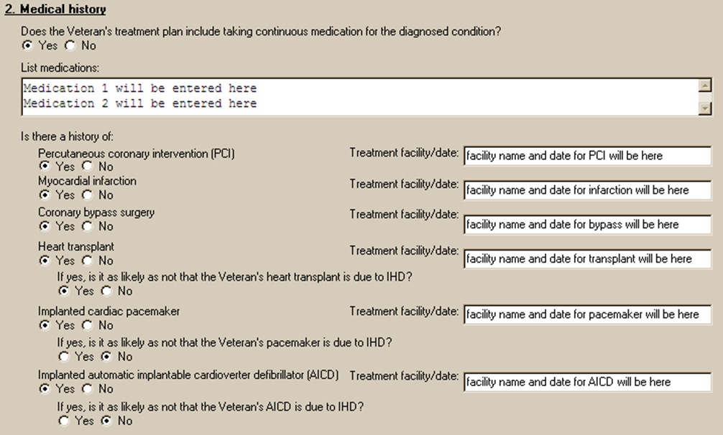

Figure 8: Print Example: DBQ – IHD – 2. Medical history

2. Medical history

------------------

Does the Veteran's treatment plan include taking continuous medication

for the diagnosed condition? [X] Yes [ ] No

List medication: Medication 1 will be entered here

Medication 2 will be entered here

Is there a history of:

Percutaneous coronary intervention (PCI) [X] Yes [ ] No

Treatment facility/date: facility name and date for PCI will be here

Myocardial infarction [X] Yes [ ] No

Treatment facility/date: facility name and date for infarction will be here

Coronary bypass surgery [X] Yes [ ] No

Treatment facility/date: facility name and date for bypass will be here

Heart transplant [X] Yes [ ] No

Treatment facility/date: facility name and date for transplant will be here

If yes, is it as likely as not that the Veteran's heart transplant is due

to IHD? [X] Yes [ ] No

Implanted cardiac pacemaker [X] Yes [ ] No

Treatment facility/date: facility name and date for pacemaker will be here

If yes, is it as likely as not that the Veteran's pacemaker is due to IHD?

[ ] Yes [X] No

Implanted automatic implantable cardioverter defibrillator (AICD)

[X] Yes [ ] No

Treatment facility/date: facility name and date for AICD will be here

If yes, is it as likely as not that the Veteran's ACID is due to IHD?

[ ] Yes [X] No

Section 3. Congestive heart failure (CHF)
All questions in this section may be answered as described by the rules below. If all mandatory questions are not answered, the error message(s) will appear in a popup window as depicted below.

Table 4: Rules: DBQ – IHD – 3. Congestive heart failure (CHF)
Field/Question | Field Disposition | Valid Values | Format | Error Message
3. Congestive heart failure (CHF) | Disabled; Read-Only | N/A | N/A | N/A
Does the Veteran have CHF? | If diagnosis = Yes; Enabled, Mandatory, Choose one valid value  Else; Enabled, Optional | [Yes; No] | N/A | Please provide an answer to the question: Does the Veteran have CHF?
Is the Veteran’s CHF chronic? | If Does the Veteran have CHF = Yes; Enabled, Mandatory, Choose one valid value  Else; Disabled | [Yes; No] | N/A | Please provide an answer to the question: Is the Veteran's CHF chronic?
If the Veteran’s CHF is not chronic, has the Veteran had more than one episode of acute CHF in the past year? | If Is the Veteran’s CHF chronic = No; Enabled, Mandatory, Choose one valid value  Else; Disabled | [Yes; No] | N/A | Please provide an answer to the question: If the Veteran's CHF is not chronic, has the Veteran had more than one episode of acute CHF in the past year?
Treatment facility/date of most recent episode of CHF: | If Is the Veteran’s CHF is not chronic, has the Veteran had more than one episode of acute CHF in the past year = Yes; Enabled, Mandatory  Else; Disabled | N/A | Free Text | Please enter the treatment facility/date of most recent episode of CHF.

Figure 9: Template Example: DBQ – IHD – 3. Congestive heart failure (CHF)
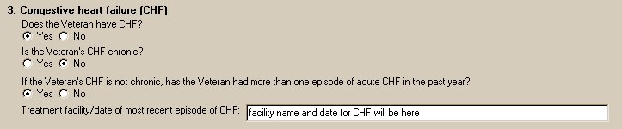

Figure 10: Print Example: DBQ – IHD – 3. Congestive heart failure (CHF)

3. Congestive heart failure (CHF)

---------------------------------

Does the Veteran have CHF? [X] Yes [ ] No

Is the Veteran's CHF chronic? [ ] Yes [X] No

If the Veteran's CHF is not chronic, has the Veteran had more than one episode

of acute CHF in the past year? [X] Yes [ ] No

Treatment facility/date of most recent episode of CHF: facility

name and date for CHF will be here

Section 4. Cardiac functional assessment
All questions in this section may be answered as described by the rules below. If all mandatory questions are not answered, the error message(s) will appear in a popup window as depicted below.

Table 5: Rules: DBQ – IHD – 4. Cardiac functional assessment
Field/Question | Field Disposition | Valid Values | Format | Error Message
4. Cardiac functional assessment | Disabled; Read-Only | N/A | N/A | N/A
Has a diagnostic exercise test been conducted? | If diagnosis = Yes; Enabled, Mandatory, Choose one valid value  Else; Enabled, Optional | [Yes; No] | N/A | Please provide an answer to the question: Has a diagnostic exercise test been conducted?
a. If yes, provide level of METs the Veteran can perform as shown by most recent diagnostic exercise testing: | If Has a diagnostic exercise test been conducted = YES; Enabled, Mandatory  Else; Disabled | N/A | Free Text | Please enter a value indicating the level of METs testing the Veteran can perform as shown by diagnostic exercise testing.
Date of most recent diagnostic exercise test: | If Has a diagnostic exercise test been conducted = YES; Enabled, Mandatory  Else; Disabled | N/A | Free Text | Please enter the date of the most recent diagnostic exercise test.
b. If exercise METs testing was not completed because it is not required as part of Veteran's treatment plan, complete the following METs test based on the Veteran's responses:  Lowest level of activity at which the Veteran reports symptoms (check all symptoms that apply) | If Has a diagnostic exercise test been conducted = No; Enabled, Mandatory, Choose one or move values  Else; Enabled, Optional | [dyspnea;  fatigue;  angina;  dizziness;  syncope] | N/A | Please check one or more boxes to indicate which symptoms occur.
 |  | [(1-3 Mets) This METs level has been found to be consistent with activities such as eating, dressing, taking a shower, slow walking (2 mph) for 1-2 blocks.; (>3-5 Mets) This METs level has been found to be consistent with activities such as light yard work (weeding) , mowing lawn (power mower), brisk walking (4 mph).;  (>5-7 METs) This METs level has been found to be consistent with activities such as golfing (without cart), mowing lawn (push mower), heavy yard work (digging).;  (>7-10 METs) This METs level has been found to be consistent with activities such as climbing stairs quickly, moderate bicycling, sawing wood, jogging (6 mph).;  The Veteran denies experiencing above symptoms with any level of physical activity.] |  | Please check one of the boxes to indicate the METs level at which symptoms occur.

Figure 11: Template Example: DBQ – IHD – 4. Cardiac functional assessment
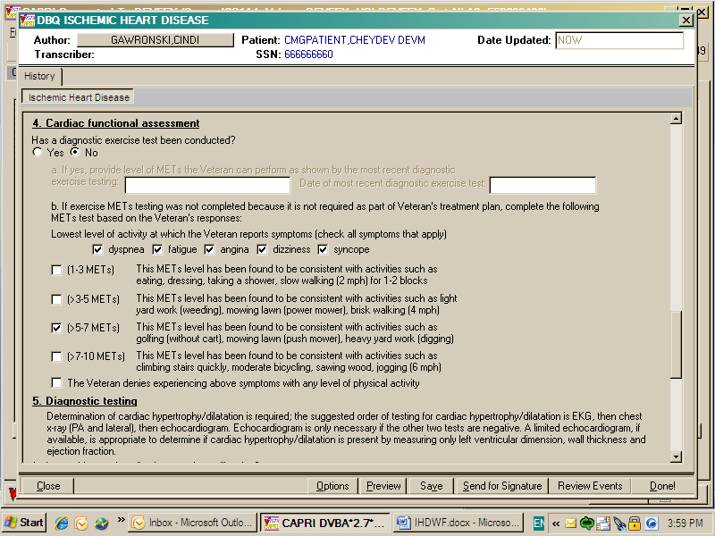

Figure 12: Print Example: DBQ – IHD – 4. Cardiac functional assessment

4. Cardiac functional assessment

--------------------------------

Has a diagnostic exercise test been conducted? [ ] Yes [X] No

a. If yes, provide level of METs the Veteran can perform as shown by

the most recent diagnostic exercise testing:

Date of most recent diagnostic exercise test:

b. If exercise METs testing was not completed because it is not required

as part of Veteran's treatment plan, complete the following METs test

based on the Veteran's responses:

Lowest level of activity at which the Veteran reports symptoms:

(check all symptoms that apply)

[X] dyspnea [X] fatigue [X] angina [X] dizziness [X] syncope

[ ] (1-3 METs) This METs level has been found to be consistent with

activities such as eating, dressing, taking a

shower, slow walking (2 mph) for 1-2 blocks

[ ] (>3-5 METs) This METs level has been found to be consistent with

activities such as light yard work (weeding),

mowing lawn (power mower), brisk walking (4 mph)

[X] (>5-7 METs) This METs level has been found to be consistent with

activities such as golfing (without cart), mowing

lawn (push mower), heavy yard work (digging)

[ ] (>7-10 METs) This METs level has been found to be consistent with

activities such as climbing stairs quickly,

moderate bicycling, sawing wood, jogging (6 mph)

[ ] The Veteran denies experiencing above symptoms with

any level of physical activity

Section 5. Diagnostic testing
All questions in this section may be answered as described by the rules below. If all mandatory questions are not answered, the error message(s) will appear in a popup window as depicted below.

Table 6: Rules: DBQ – IHD – 5. Diagnostic testing
Field/Question | Field Disposition | Valid Values | Format | Error Message
5. Diagnostic testing | Disabled; Read-Only | N/A | N/A | N/A
Determination of cardiac hypertrophy/dilatation is required; the suggested order of testing for cardiac hypertrophy/dilatation is EKG, then chest x-ray (PA and lateral), then echocardiogram. Echocardiogram is only necessary if the other two tests are negative. A limited echocardiogram, if available, is appropriate to determine if cardiac hypertrophy/dilatation is present by measuring only left ventricular dimension, wall thickness and ejection fraction. | Disabled, Read-Only | N/A | N/A | N/A
Is there evidence of cardiac hypertrophy or dilatation? | If diagnosis = Yes; Enabled, Mandatory, Choose one valid value  Else; Enabled, Optional | [Yes; No] | N/A | Please provide an answer to the question: Is there evidence of cardiac hypertrophy or dilatation?
Diagnostic test (provide most recent test only) | If previous question = Yes, Enabled, Mandatory, Choose one or more valid value  Else; Enabled, Optional | [EKG; Chest x-ray; Echocardiogram;  Other study (specify)] | N/A | Please check one or more boxes to specify the diagnostic test(s) performed.
Date of EKG | If EKG = Yes; Enabled, Mandatory  Else; Disabled | N/A | Free Text | Please enter the date of the most recent EKG.
Date of CXR: | If Chest x-ray = Yes; Enabled, Mandatory  Else; Disabled | N/A | Free Text | Please enter the date of the most recent CXR.
Date of echocardiogram: | If echocardiogram = Yes; Enabled, Mandatory  Else; Disabled | N/A | Free Text | Please enter the date of the most recent echocardiogram.
Name of other diagnostic test study | If Other study = Yes; Enabled, Mandatory  Else; Disabled | N/A | Free Text | Please specify the name of the other diagnostic test study.
Date of other study: | If Other study = Yes; Enabled, Mandatory  Else; Disabled | N/A | Free Text | Please enter the date of the most recent other study.
Left ventricular ejection fraction (LVEF), if known: | Enabled, Optional | N/A | Free Text % | N/A
Date of test: | If LVEF is populated; Enabled, Mandatory  Else; Enabled, Optional | N/A | Free Text | Please enter the date of the LVEF test.
If LVEF testing is not of record, but available medical information sufficiently reflects the severity of the Veteran’s cardiovascular condition, LVEF testing is not required. | Disabled, Read-Only | N/A | N/A | N/A

Figure 13: Template Example: DBQ – IHD – 5. Diagnostic testing
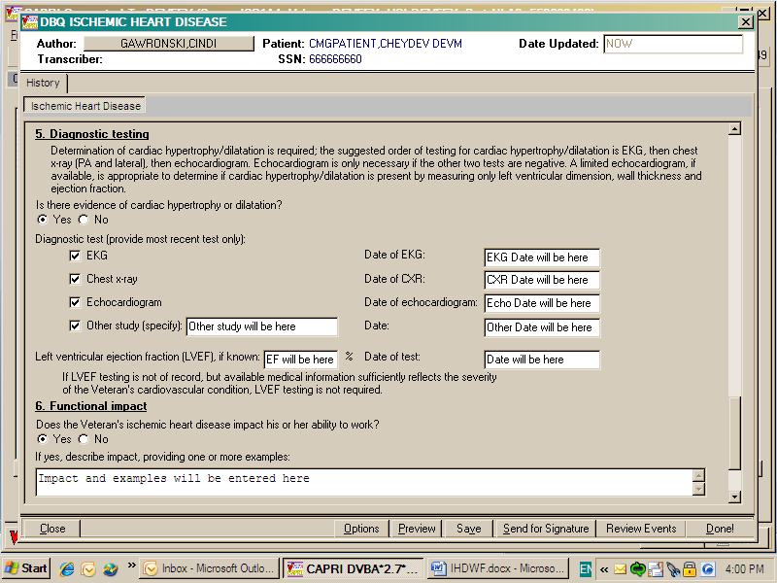

Figure 14: Print Example: DBQ – IHD – 5. Diagnostic testing

5. Diagnostic testing

---------------------

Determination of cardiac hypertrophy/dilatation is required; the suggested

order of testing for cardiac hypertrophy/dilatation is EKG, then chest x-

ray (PA and lateral), then echocardiogram. Echocardiogram is only necessary

if the other two tests are negative. A limited echocardiogram, if

available, is appropriate to determine if cardiac hypertrophy/dilatation is

present by measuring only left ventricular dimension, wall thickness and

ejection fraction.

Is there evidence of cardiac hypertrophy or dilatation?

[X] Yes [ ] No

Diagnostic test (provide most recent test only):

[X] EKG Date of EKG: EKG Date will be here

[X] Chest x-ray Date of CXR: CXR Date will be here

[X] Echocardiogram Date of echocardiogram: Echo Date will be here

[X] Other study (specify): Other study will be here

Date:Other Date will be here

Left ventricular ejection fraction (LVEF), if known: LVEF will be here %

Date of test: Date will be here

If LVEF testing is not of record, but available medical information

sufficiently reflects the severity of the Veteran's cardiovascular

condition, LVEF testing is not required.

Section 6. Functional impact
All questions in this section may be answered as described by the rules below. If all mandatory questions are not answered, the error message(s) will appear in a popup window as depicted below.

Table 7: Rules: DBQ – IHD – 6. Functional impact
Field/Question | Field Disposition | Valid Values | Format | Error Message
6. Functional impact | Disabled; Read-Only | N/A | N/A | N/A
Does the Veteran’s ischemic heart disease impact his or her ability to work? | If diagnosis = Yes; Enabled, Mandatory, Choose one valid value  Else; Enabled, Optional | [Yes; No] | N/A | Please provide an answer to the question: Does the Veteran’s ischemic heart disease impact his or her ability to work?
If yes, describe impact, providing one or more examples: | If Does the Veteran’s ischemic heart disease impact his or her ability to work = Yes; Enabled, Mandatory  Else; Disabled | N/A | Free Text | Please describe the impact of IHD on the Veteran's ability to work, providing one or more examples.

Figure 15: Template Example: DBQ – IHD – 6. Functional impact
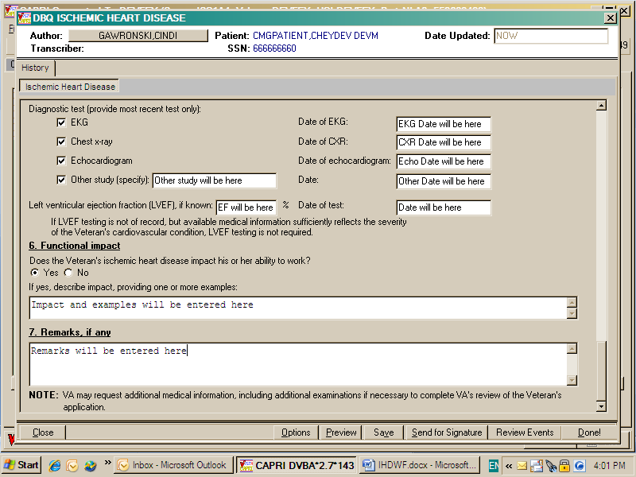

Figure 16: Print Example: DBQ – IHD – 6. Functional impact

6. Functional impact

--------------------

Does the Veteran's ischemic heart disease impact his or her ability to work?

[X] Yes [ ] No

If yes, describe impact, providing one or more examples: Impact and examples

will be entered here

Section 7. Remarks, if any
All questions in this section may be answered as described by the rules below.

Table 8: Rules: DBQ – IHD – 7. Remarks, if any
Field/Question | Field Disposition | Valid Values | Format | Error Message
7. Remarks, if any | Enabled, Optional | N/A | Free Text | N/A

Figure 17: Template Example: DBQ – IHD – 7. Remarks, if any

Figure 18: Print Example: DBQ – IHD – 7. Remarks, if any

7. Remarks, if any

------------------

Remarks will be entered here

IHD AMIE-DBQ Worksheet
The AMIE-DBQ worksheets are accessed via the [DVBA C PRINT BLANK C&P WORKSHE] Print Blank C&P Worksheet DBQ-Ischemic Heart Disease menu option.

Disability Benefits Questionnaire
Ischemic Heart Disease (IHD)

Name of patient/Veteran: _______________________ SSN: ________________

Your patient is applying to the U. S. Department of Veterans Affairs
(VA) for disability benefits. VA will use the information you provide on
this questionnaire to process the Veteran's claim.

1. Diagnosis

NOTE: IHD includes, but is not limited to, acute, subacute, and old
myocardial infarction; atherosclerotic cardiovascular disease including
coronary artery disease (including coronary spasm) and coronary bypass
surgery; and stable, unstable and Prinzmetal's angina. IHD does not include
hypertension or peripheral manifestations of arteriosclerosis such as
peripheral vascular disease or stroke, or any other condition that does not
qualify within the generally accepted medical definition of ischemic heart
disease.
IHD encompasses any atherosclerotic heart disease resulting in clinically
significant ischemia or requiring coronary revascularization.

Does the Veteran have ischemic heart disease (IHD)? ___ Yes ___ No

NOTE: Provide only diagnoses that pertain to IHD.
Diagnosis #1: _______________________
ICD code: ___________________________
Date of diagnosis #1: _______________

Diagnosis #2: _______________________
ICD code: ___________________________
Date of diagnosis #2: _______________

Diagnosis #3: _______________________
ICD code: ___________________________
Date of diagnosis #3: _______________

If additional diagnoses that pertain to IHD, list using above format:
_____________________

Page: 2

Disability Benefits Questionnaire for
Ischemic Heart Disease (IHD)

2. Medical history

Does the Veteran's treatment plan include taking continuous medication for
the diagnosed condition? ___ Yes ___ No
List medications: _______________________________________________________

Is there a history of:

Percutaneous coronary intervention (PCI) ___ Yes ___ No
Treatment facility/date:_________________________________________________

Myocardial infarction ___ Yes ___ No
Treatment facility/date:_________________________________________________

Coronary bypass surgery ___ Yes ___ No
Treatment facility/date:_________________________________________________

Heart transplant ___ Yes ___ No
Treatment facility/date:_________________________________________________
If yes, is it as likely as not that the Veteran's heart transplant is
due to IHD? ___ Yes ___ No

Implanted cardiac pacemaker ___ Yes ___ No
Treatment facility/date:_________________________________________________
If yes, is it as likely as not that the Veteran's pacemaker is due to
IHD? ___ Yes ___ No

Implanted automatic implantable cardioverter defibrillator (AICD)
___ Yes ___ No
Treatment facility/date: ________________________________________________
If yes, is it as likely as not that the Veteran's AICD is due to IHD?
___ Yes ___ No

3. Congestive heart failure (CHF)
Does the Veteran have CHF? ___ Yes ___ No
Is the Veteran's CHF chronic? ___ Yes ___ No

If the Veteran's CHF is not chronic, has the Veteran had more than one
episode of acute CHF in the past year? ___ Yes ___ No

Treatment facility/date of most recent episode of CHF: _______________________

______________________________________________________________________________

Page: 3

Disability Benefits Questionnaire for
Ischemic Heart Disease (IHD)

4. Cardiac functional assessment

Has a diagnostic exercise test been conducted? ___ Yes ___ No

a. If yes, provide level of METs the Veteran can perform as shown by the
most recent diagnostic exercise testing: _______________

Date of most recent diagnostic exercise test:___________

b. If exercise METs testing was not completed because it is not required as
part of Veteran's treatment plan, complete the following METs test based on
the Veteran's responses:

Lowest level of activity at which the Veteran reports symptoms (check all
symptoms that apply)

___ dyspnea ___ fatigue ___ angina ___ dizziness ___ syncope

___ (1-3 METs) This METs level has been found to be consistent with
activities such as eating, dressing, taking a shower,
slow walking (2 mph) for 1-2 blocks

___ (>3-5 METs) This METs level has been found to be consistent with
activities such as light yard work (weeding), mowing lawn
(power mower), brisk walking (4 mph)

___ (>5-7 METs) This METs level has been found to be consistent with
activities such as golfing (without cart), mowing lawn
(push mower), heavy yard work (digging)

___ (>7-10 METs) This METs level has been found to be consistent with
activities such as climbing stairs quickly, moderate
bicycling, sawing wood, jogging (6 mph)
___ The Veteran denies experiencing above symptoms with any level of
physical activity

Page: 4

Disability Benefits Questionnaire for
Ischemic Heart Disease (IHD)

5. Diagnostic testing

Determination of cardiac hypertrophy/dilatation is required; the suggested
order of testing for cardiac hypertrophy/dilatation is EKG, then chest
x-ray (PA and lateral), then echocardiogram. Echocardiogram is only
necessary if the other two tests are negative. A limited echocardiogram, if
available, is appropriate to determine if cardiac hypertrophy/dilatation is
present by measuring only left ventricular dimension, wall thickness and
ejection fraction.

Is there evidence of cardiac hypertrophy or dilatation?
___ Yes ___ No

Diagnostic test (provide most recent test only):

___ EKG Date of EKG: ______________
___ Chest x-ray Date of CXR: ______________
___ Echocardiogram Date of echocardiogram:_______________
___ Other study (specify): ________ Date:_______________

Left ventricular ejection fraction (LVEF), if known: ______%
Date of test: ________________

If LVEF testing is not of record, but available medical information
sufficiently reflects the severity of the Veteran's cardiovascular condition,
LVEF testing is not required.

6. Functional impact
Does the Veteran's ischemic heart disease impact his or her ability to work?

___ Yes ___ No

If yes, describe impact, providing one or more examples: ____________________

_____________________________________________________________________________

Page: 5

Disability Benefits Questionnaire for
Ischemic Heart Disease (IHD)

7. Remarks, if any

____________________________________________________________________________

Physician signature: ________________________________________ Date:__________

Physician printed name: _____________________________________ Phone:_________

Medical license #: __________________

Physician address: __________________________________________________________

NOTE: VA may request additional medical information, including additional
examinations if necessary to complete VA's review of the Veteran's
application.

